Submitted By:
Hafiza Aliza Mustafa
Internship Report:
Air Quality Index (AQI) Prediction System Using a Fully Serverless MLOps Pipeline
1. Introduction
Air pollution has become one of the most critical environmental challenges worldwide, particularly in densely populated urban regions. Poor air quality directly impacts public health, economic productivity, and overall quality of life. To quantify air pollution levels and communicate risks to the public, the Air Quality Index (AQI) is widely used.
This internship project focuses on developing a fully automated, serverless machine learning system to predict the Air Quality Index (AQI) for Karachi for the next 72 hours (3 days). The system is designed following modern MLOps best practices, incorporating automated data ingestion, feature engineering, model training, model registry management, and real-time prediction visualization.
The project demonstrates how machine learning pipelines can be deployed in a scalable, maintainable, and production-ready manner using cloud-native and serverless tools.

2. Objectives
The main objectives of this internship project are:
- To collect historical and real-time weather and pollutant data automatically.
- To engineer meaningful features required for AQI forecasting.
- To train and evaluate machine learning models for short-term AQI prediction.
- To automate data ingestion and model retraining using CI/CD pipelines.
- To deploy an interactive dashboard for real-time and forecasted AQI visualization.
- To implement a fully serverless architecture requiring minimal manual maintenance.

3. Problem Statement
Manual monitoring and static analysis of air quality data are insufficient for real-time decision-making. Many existing systems lack automation, scalability, or predictive capabilities.
The problem addressed in this project is the lack of an automated, continuously updating AQI forecasting system that can ingest real-time data, retrain itself periodically, and provide accurate short-term predictions to users in an interpretable manner.

4. System Overview
The developed system is an end-to-end AQI prediction pipeline consisting of four major components:
- Data Collection and Feature Pipeline
- Model Training and Evaluation Pipeline
- Automation and CI/CD Layer
- Deployment and Visualization Layer
Each component is modular and loosely coupled, allowing independent updates and scalability.
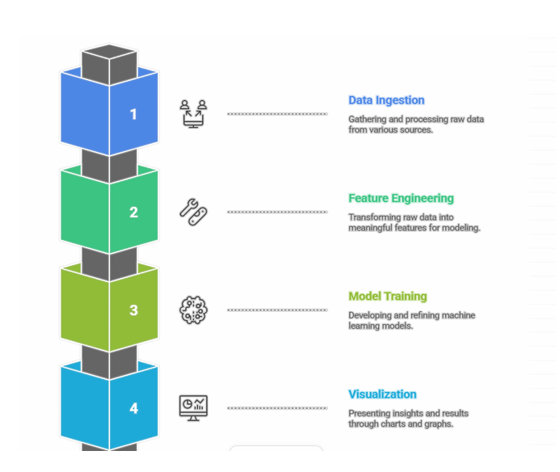

5. Technology Stack
The technologies used in this project are summarized below:
- Programming Language: Python
- Data Source: Open-Meteo API
- Feature Store: Hopsworks
- Model Registry: Hopsworks
- Machine Learning Library: scikit-learn
- Model Used: Random Forest Regressor
- Automation: GitHub Actions
- Web Framework: Streamlit
- Architecture Type: Fully Serverless

6. Data Collection

6.1 Data Source
Weather and pollutant data are collected using the Open-Meteo API, which provides hourly measurements for environmental variables relevant to AQI prediction.

6.2 Features Collected
The collected data includes:
- Temperature (2m)
- Relative humidity
- Dew point
- Apparent temperature
- Precipitation
- Rain and snowfall
- Surface pressure
- Cloud cover
- Wind speed and wind direction
- Pollutant indicators (PM2.5, PM10, NO₂, CO)

6.3 Historical Dataset
The script open_metro_1_year.py fetches one year of historical data (December 2024 – December 2025). The dataset is stored locally as:
karachi_weather_pollutants_2024_2025.csv
This dataset serves as the foundation for initial model training.

7. Feature Engineering and Feature Store Management
Feature engineering is handled through the script open_metro_hopswork_pushed_v3.py.

Key responsibilities:
- Uploading historical data to the Hopsworks Feature Store
- Fetching new hourly data from Open-Meteo API
- Appending fresh records to the feature store
- Ensuring feature consistency between training and inference
The feature pipeline runs automatically every hour via GitHub Actions, ensuring that the system always has access to the latest data.

8. Model Training Pipeline

8.1 Model Selection
A Random Forest Regressor is used due to:
- Its robustness to non-linear relationships
- Ability to handle mixed-scale features
- Strong performance on tabular environmental data

8.2 Training Process
The script AQI_Model_training_v2.py performs the following steps:
- Pulls feature data from the Hopsworks Feature Store
- Splits data into training and validation sets
- Trains the Random Forest model
- Evaluates performance using:
  - Root Mean Squared Error (RMSE)
  - Mean Absolute Error (MAE)
  - R² Score
- Saves the trained model:
  - Locally in aqi_model_push/
  - In the Hopsworks Model Registry

8.3 Automation
The model training pipeline is executed every 12 hours using GitHub Actions, enabling continuous learning and adaptation to new data.

9. Automation and CI/CD
Automation is a core component of this project.

CI/CD responsibilities include:
- Hourly execution of the feature ingestion pipeline
- Periodic retraining of the machine learning model
- Elimination of manual intervention
- Continuous system reliability
GitHub Actions is used to schedule and manage all automated tasks, ensuring the system remains fully serverless and maintenance-free.

10. Deployment and Visualization

10.1 Streamlit Dashboard
The trained model is deployed through a Streamlit web application (app_streamlit_aqi_v6.py).

Dashboard Features:
- Display of current AQI values
- Forecasted AQI for the next 72 hours
- Interactive visualizations and trend analysis
The dashboard loads the latest model from the Model Registry and uses the most recent feature data for inference.

11. Results and Observations
- The system successfully predicts AQI trends for the next three days.
- Automated retraining ensures improved adaptability over time.
- The dashboard provides an intuitive and user-friendly interface.
- The system operates entirely without manual maintenance.

12. Challenges Faced
- Handling real-time data ingestion consistency
- Feature alignment between training and inference
- Automating model retraining without downtime
- Managing secure access to cloud services
These challenges were resolved using feature stores, model registries, and CI/CD automation.

13. Conclusion
This internship project successfully demonstrates a production-grade AQI prediction system using modern MLOps principles. The solution integrates data engineering, machine learning, automation, and deployment into a unified serverless architecture.
The project fulfills all internship objectives and provides a strong foundation for real-world environmental monitoring and forecasting applications.

14. Future Improvements
Potential enhancements include:
- Integration of deep learning models (LSTM, Temporal CNN)
- Explainability using SHAP or LIME
- AQI alert system for hazardous levels
- Multi-city AQI forecasting
- Cloud deployment for public access

15. References
- Open-Meteo API Documentation
- Hopsworks Feature Store Documentation
- scikit-learn Documentation
- GitHub Actions Documentation

